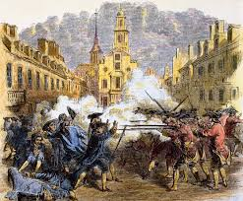 The Boston Massacre

Review: The King of England, George II, made a deal with the American colonists. He vowed to protect the Americans from the French and the Indians and to give them rights to the territories of Quebec and the Ohio Valley in exchange for their military assistance in the Seven Year’s War (or French and Indian War). Delegates from the colonies met in Albany for the Albany Congress and after debate and discussion resigned to accept the deal.

The Americans and British won the war and drove France from North America. Subsequently, the king died and his son, King George III, was crowned the new King of England. King George III effectively told the colonists, “the deal died with my father,” and did not give the colonists the promised territories, but instead gave them new taxes. The war was incredibly expensive and put the royal treasury in great depth. In order to restore the budget, George III urged Parliament to tax the American Colonists.

As per British Law, the only government officials with the authority to levy taxes are Representatives or officials who were voted into office. For instance, the King or Queen did not have the authority to levy taxes because they were not voted into power. Members of Parliament get their jobs because people vote for them, therefore they had the authority to levy taxes. The colonists argued they cannot be taxed because they did not have the right to vote, or they had no Representation. They correctly claimed their can be no taxation without representation. Parliament and the King heard their pleas and said, “maybe, but we’re taxing you anyway,” and ratified a series of new taxes and laws, The Towshend Acts.

Once again, the colonists met, this time in Philadelphia in to form the First Continental Congress to decide what to do. Some argued they should just pay the tax, others proposed they attempt to negotiate and work things out, and others still made the case the colonies should break free of England altogether and form their own country. Tensions were high and British Soldiers, were mobilized and dispatched the American Colonies to maintain order.

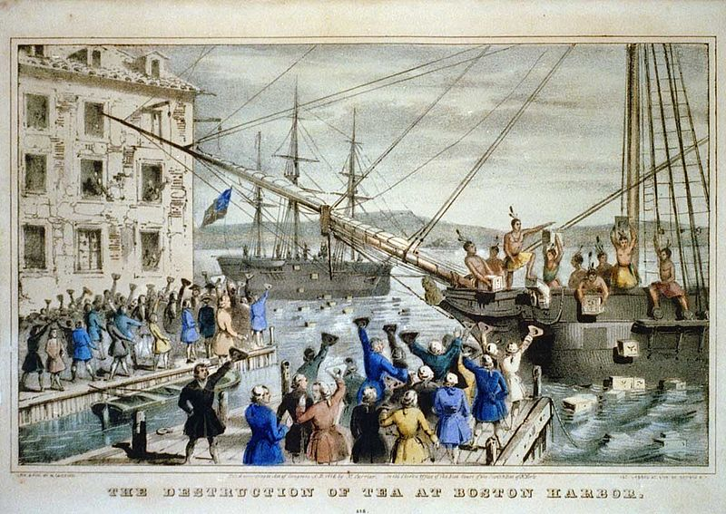 The Boston Tea Party.

For this assignment, you do not need your book, but you are welcome to use it if it helps.
Part I. Based on the video “The Revolution: Bloody Boston” answer any five questions (one point each).
https://www.youtube.com/watch?v=QParA8h9UY4&list=PLMZhrNNj_z5tnKucoERFbWHB1zPoCHvYG
- What was the general goal of the Sons of Liberty and why were they use harsh violence against Loyalists or Tories?
- What was Patrick Henry’s argument against the British Taxes and was he right?
- Why was Benjamin Franklin a very important figure within the relationship between England/London and the Colonies?
- How did the Colonists win the political victory in repealing the Stamp Tax?
- How did the Patriots and Sons of Liberty portray the Boston Massacre?
- Why was John Adams determined to defend the British Soldiers even though he was a colonial Patriot?
- How did the British Government respond to the Boston Tea Party?
- How did the delegates at the First Continental Congress risk their lives to meet and discuss the best course of action?
- Why did the Congress have a difficult time working out a solution to the problems before them?
- Is if fair for Paul Revere to get all the credit for altering the colonists “The British are coming?”
- Why was the Battle of Lexington and Concord and the Shot Heard Around the World a turning point when the problems between the Colonies and London could no longer be resolved?

Part II.
Base your responses on the Declaring Independence video and your insight (link below). There is no need for additional research, in fact do not look to other sources. Answer any five questions (one point each). Please type or copy the questions as you answer them. Each response should be approximately two or three sentences each (no longer). Any plagiarism from another source or website will result in a zero.

Remember, the Continentals surprised the British at Boston in 1775 during the Battle of Bunker Hill. Afterward, the King unleashed massive numbers of Red Coats under the command of General William Howe to once and for all crush the Rebellion. In Philadelphia, the Continental Congress had moved to separate from the Throne and Declare Independence.

Revolution and Independence
https://www.youtube.com/watch?v=pNKKpHZazy4

- Why was the city of New York important for the outcome of the war?
- Why was Paine and interesting figure in articulating the voice of the separatists?
- What were Washington’s fears about defeating the British at New York?
- Why was their a disconnect between Washington in New York and Congress in Philadelphia.
- What thoughts did Jefferson wrestle with when writing the Declaration of Independence?
- What did Jefferson write or want to write about slavery and what did Congress say about it?
- Why did Howe and the British hesitate to attack New York in the summer or 1775?
- How did the Founders risk their lives in voting for independence?
- What mistakes did Washington make at the Battle of New York?
- What mistakes did William Howe make at the Battle of New York?
- How did “Lucky” Washington’s skill are retreating (running away) factor in the Battle of New York?
- Did the British win or lose the Battle of New York?

I want to note an error in the video. Thomas Paine did not call his pamphlet Common Sense, Congress, Ben Franklin specifically, renamed it to Common Sense. Extra Credit for any who can tell me the original name.
This is due Wednesday, July 7th at 11:59 PM.

